[ZANG] - [Chuanjie] - ITCAssignment

Student ID: 699382953

[chuanjiezang@gmail.com](mailto:chuanjiezang@gmail.com)

Task 1

Create the new file (myfile1.txt) in your system, use the who command, and redirect the result to a file called myfile1. Use the more command to see the contents of myfile1.

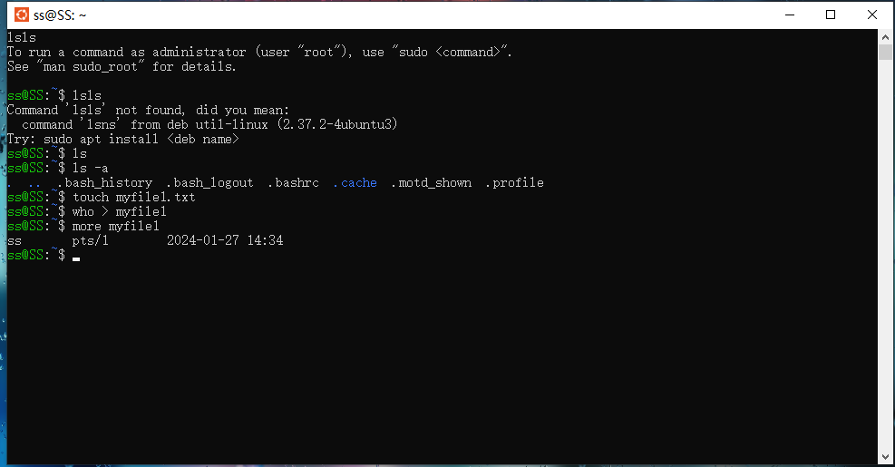

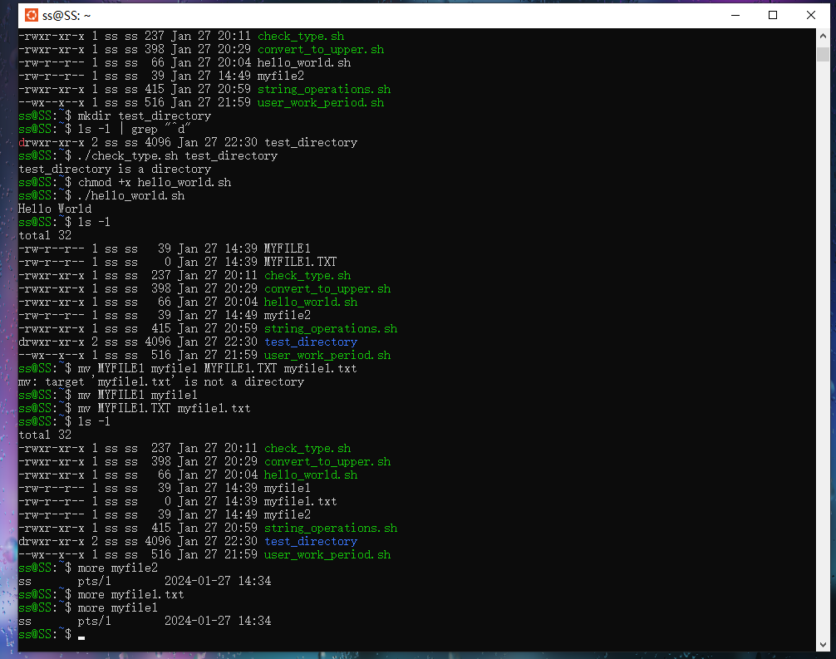

Task 2:

Create the new file myfile2 in your system, Use the date and who commands in a sequence (in one line) such that the output of date will display on the screen and the output of who will be redirected to a file called myfile2. Use the more command to check the contents of myfile2.

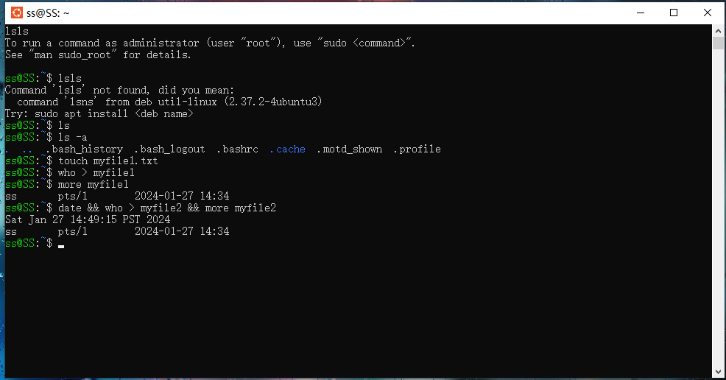

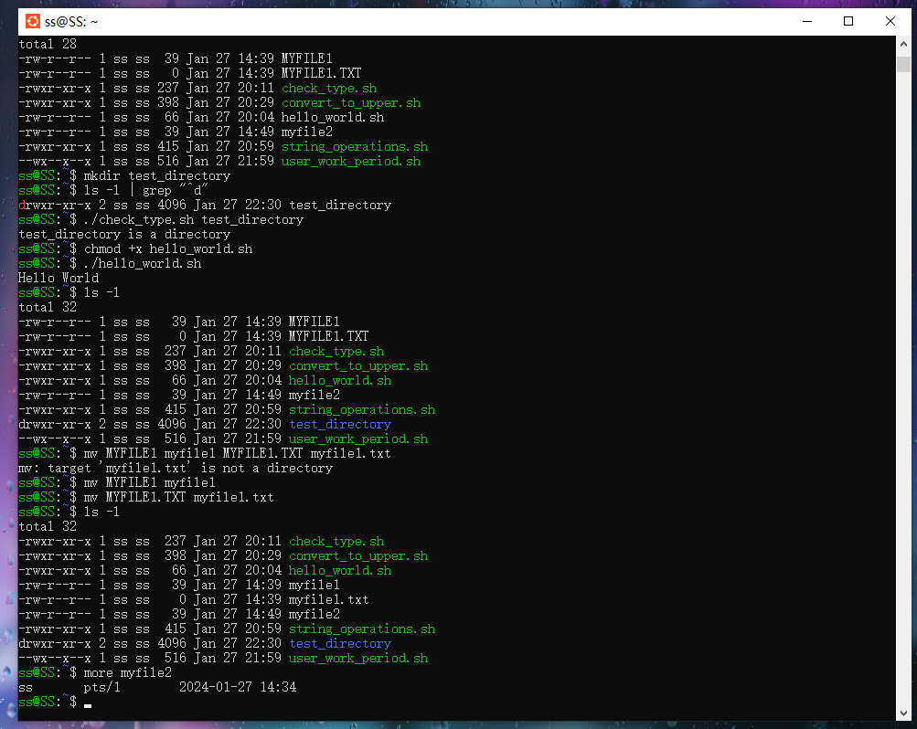

Task 3:

Write a shell script program to display “HELLO WORLD”.

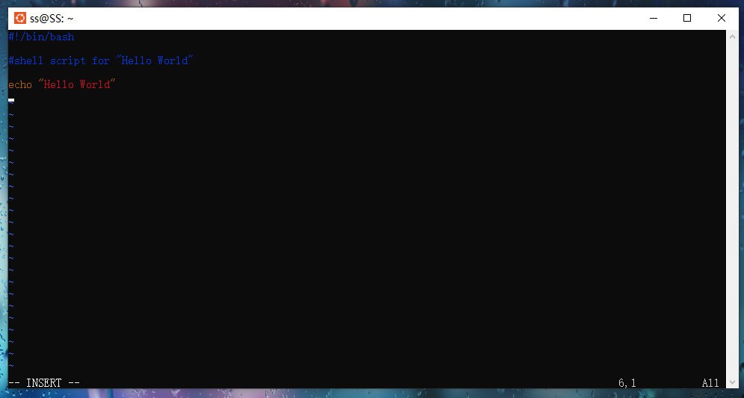

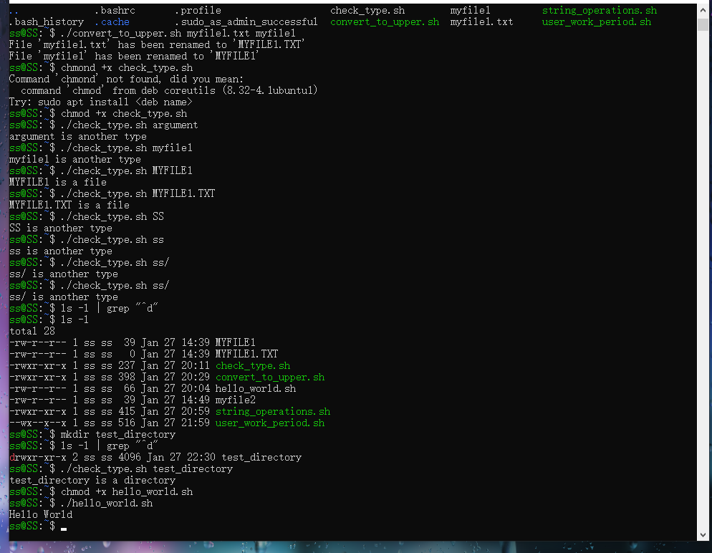

Task 4:

Write a shell script that takes a command‐line argument and reports on whether it is a directory, file, or something else.

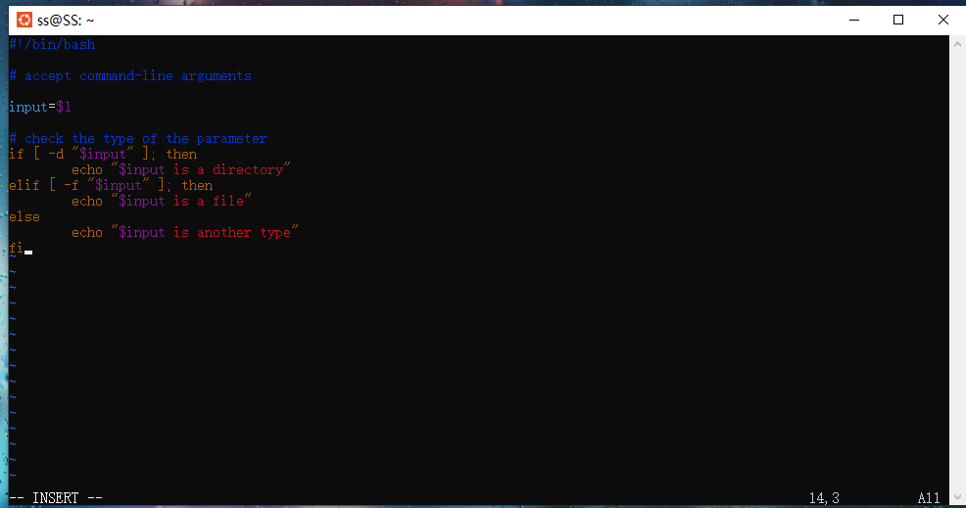

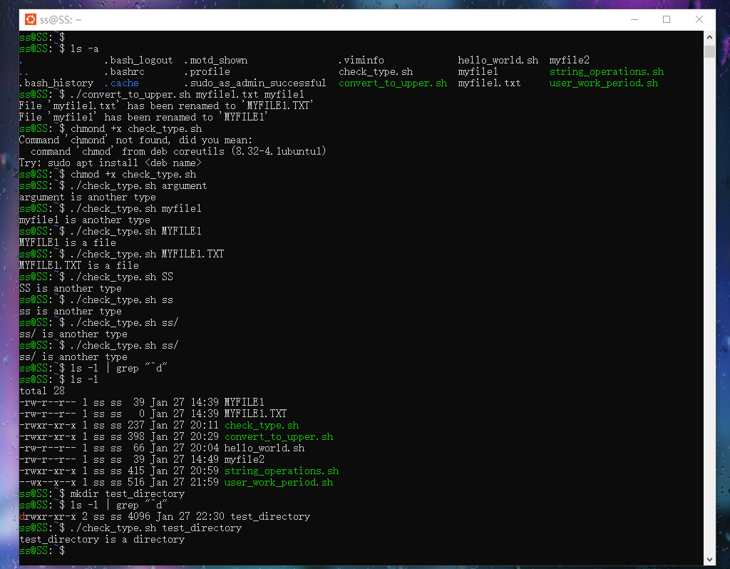

Task 5:

Write a shell script that accepts one or more file names as arguments and converts all of them to uppercase, provided they exist in the current directory.

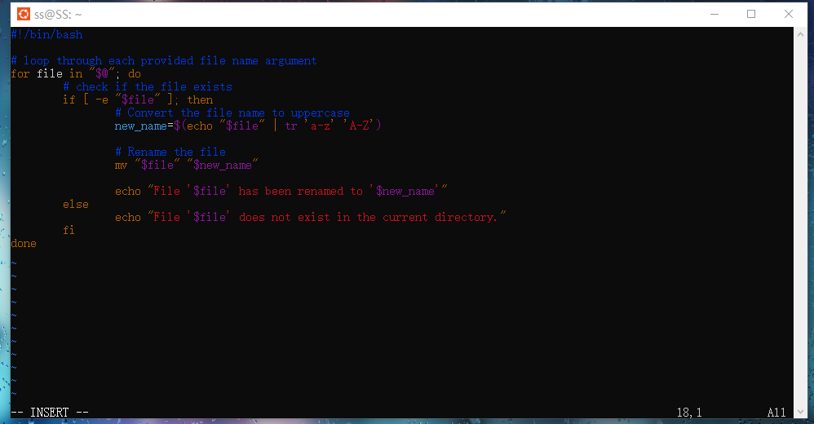

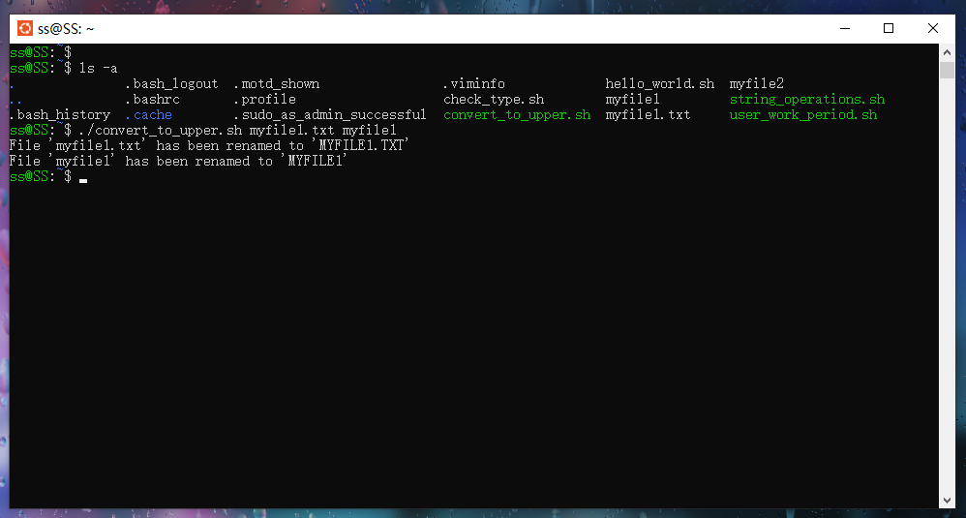

Task 6:

Write a shell script that determines the period during which a specified user is working on the system.

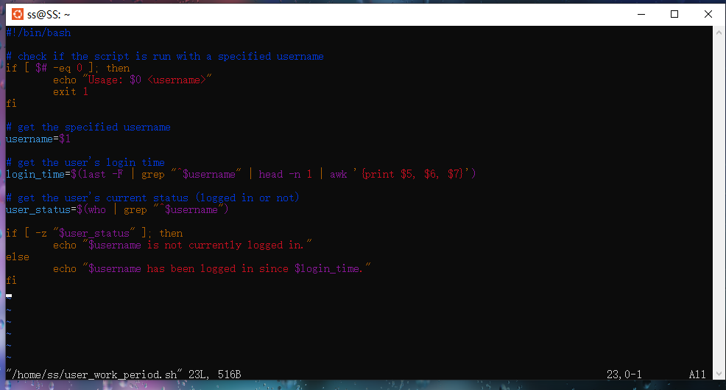

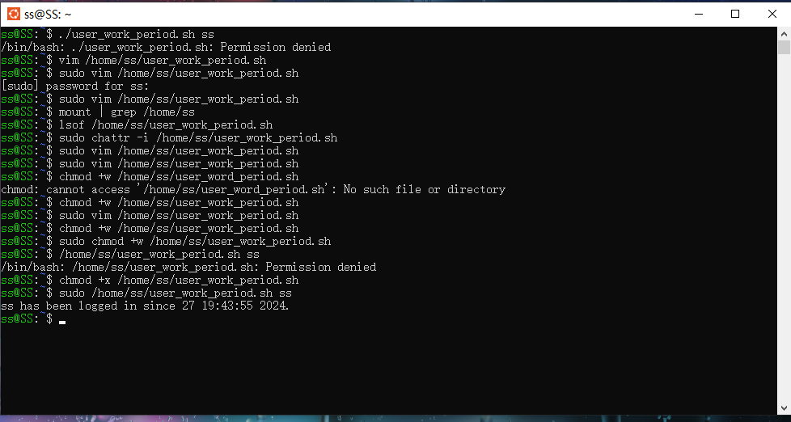

Task 7:

Write a shell script to perform the following string operations:

(a) To extract a sub‐string from a given string.

(b) To find the length of a given string

